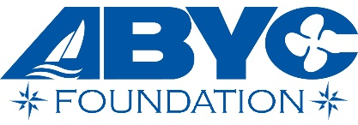

Jack Hornor Scholarship Application for Post-Secondary Career Technical Education

Applicant Information
Full Name: |  |  |  | Date:
 | Last | First | M.I.

Address:
 | Street Address | Apartment/Unit #

 | City | State | ZIP Code

Phone: |  | Email

Desired Amount: | $
We do our best to provide the desired amount, but due to funding and demand, we must take each application under consideration individually

School Information

Name of School you Are Attending or Plan to Attend:

Address:
 | Street Address | Apartment/Unit #

 | City |  |  | State | ZIP Code
Contact: |  | Email

Experience & Activities

Please supply a document indicating current and/or future interest in the marine industry:
academic honors awards, membership activities, hobbies, outside interests, volunteer activities, employment

Interest in Marine Industry

Please include a short essay explaining why you wish to pursue a career in the marine industry, including how you became interested and how you envision your future

-continue on page two-

References
Please include two letters of academic reference with this application
Full Name: |  | Relationship:
School: |  | Phone:
Address:
Full Name: |  | Relationship:
School: |  | Phone:
Address:

Disclaimer and Signature
I certify that my answers are true and complete to the best of my knowledge.
If this application leads to employment, I understand that false or misleading information in my application or interview may result in my release.
Signature: |  | Date:

Please return to:

Sarah Devlin
Accreditation Director
ABYC Foundation
sdevlin@abycinc.org
410-990-4460

